Discussion 1
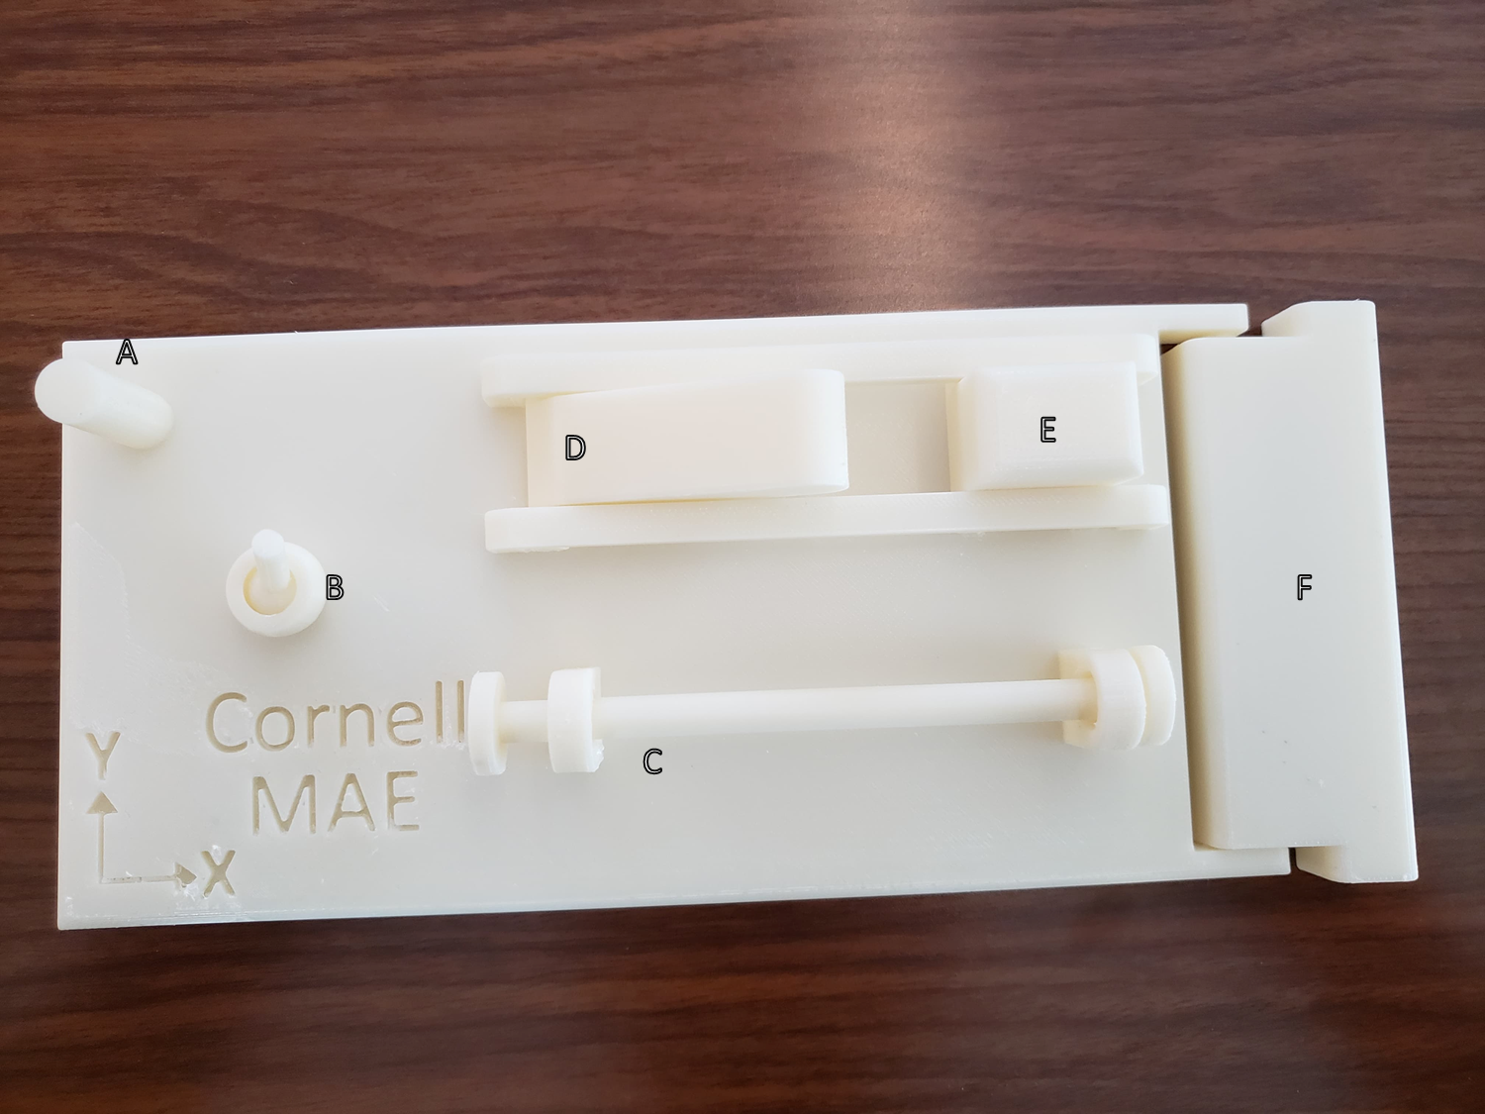
Figure 1. Toy with six elements (A-F) demonstrating unique boundary conditions.

Instructions
For each element:
Force
- Sequentially apply a force in the $x, y,$ and $z$-directions (treat elements D and E as two-dimensional and only apply forces in the $x$ and z-directions).
- Take note of which elements can generate reactions to which forces at supports.
- Draw a free-body diagram (FBD) for each element in the second page, showing only the applicable reactions $F_{x}, F_{y}, F_{z}$ at supports.
- Describe what motions (if any) are permitted.
Moment
- Apply a moment about the $x, y,$ and $z$-directions (for elements D and E, only consider the $y$-axis.).
- Add the applicable reaction moments to your FBD’s.
- Describe what motions (if any) are permitted.

Elements
A.

B.

C.

D.

E.

F.

Complete the table below by putting a “$√$” in each box if the element can produce the relevant reaction force $F_{x}, F_{y}, F_{z}$ or reaction moment $M_{x}, M_{y}, M_{z}$.

 | Possible Reactions
Element | $$F_{x}$$ | $$F_{y}$$ | $$F_{z}$$ | $$M_{x}$$ | $$M_{y}$$ | $$M_{z}$$
A
B
C
D
E
F

In the following table, identify the element depicted in each drawing (see tables 4.1 and 4.10 in the book for more examples).
Drawing Representation | Toy Element
